ClubUML

CSYE7945 Spring 2013

[Sequence Diagram Support]

[Prashant]

[Zessie]

[Yingjie,Wang]

[3/11/2013]

Revision: [1.0]

Table of Contents

Introduction 3

Tools 4

UML Generation Tool 4

Graphing Tool 4

Pic2Plot Installation Guide 5

Sequence Diagram Visualization Flow 6

Details 7

Conclusion and To-Do list 9

# Introduction

In order to integrate sequence diagram in existing system, this document demonstrates the feasibility of integration.

# Tools

## UML Generation Tool

Papyrus

## Graphing Tool

UMLGraph

Pic2Plot

# Pic2Plot Installation Guide

**Download Path:**

<http://gnuwin32.sourceforge.net/packages/plotutils.htm>

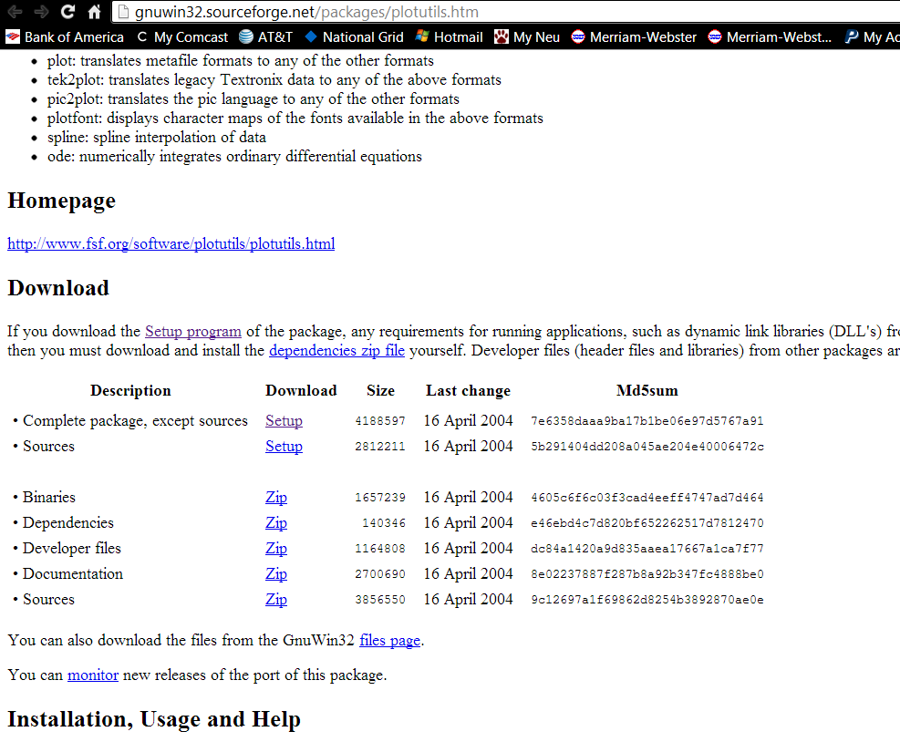

**Set Up Environment Variable:**

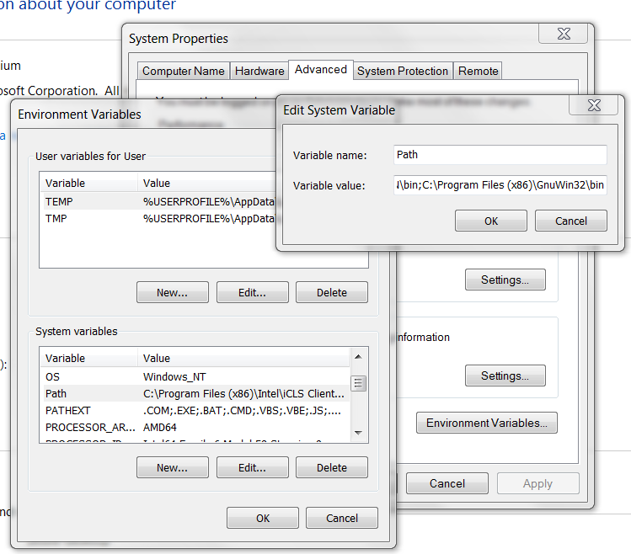

# Sequence Diagram Visualization Flow

**UML Graph**

# 

**Papyrus**

**.di file +.notation file +.uml file**

**To Be Tested**

# 

.png File

**Pic2Plot Program**

**Feasibility has been tested**

**.pic File**

# Example Implementation Details

Once we have the original papyrus sequence files, we can create a .pic file which defines the sequence diagram in textual format.

**Test Folder Before Execution:**

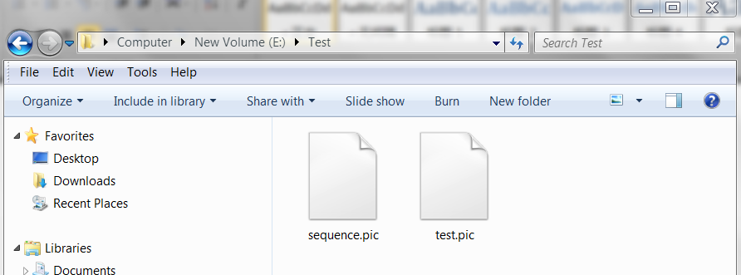

**.Pic Definition File:**

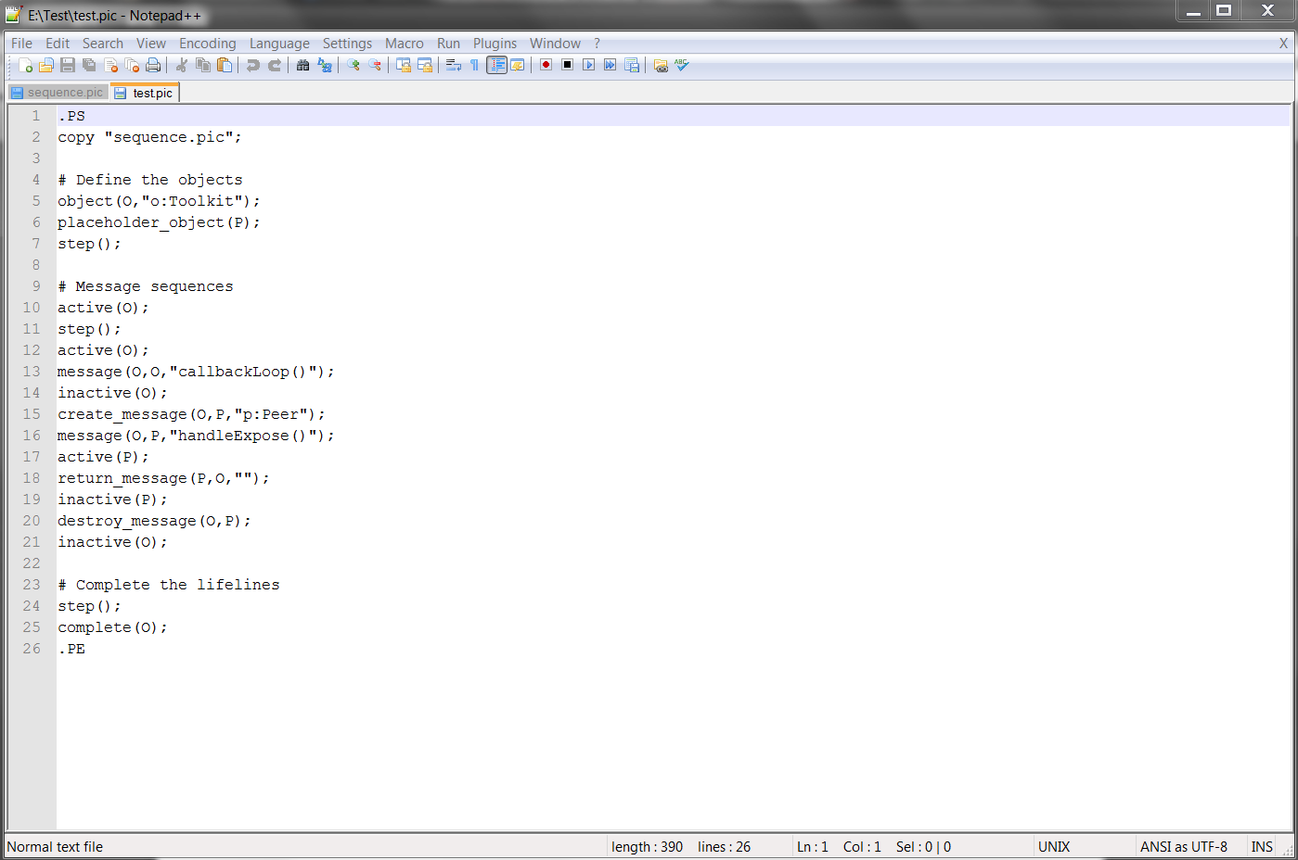

**Execution Command Line:**

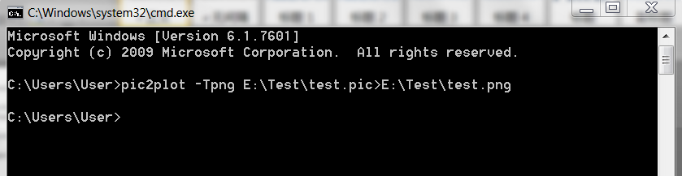

**Test Folder After Execution:**

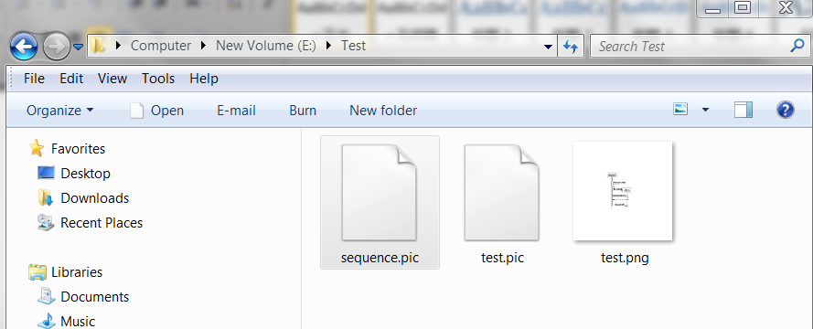

**.PNG Display File**

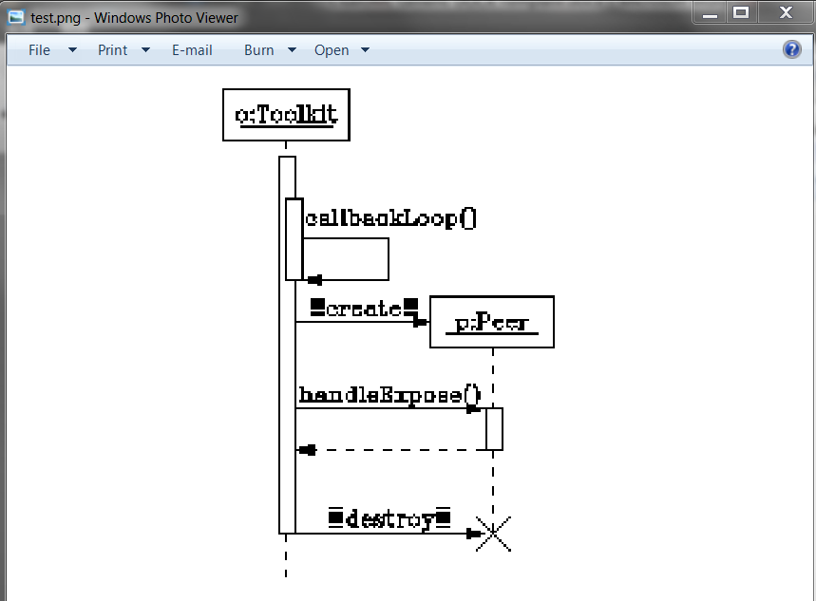

# Conclusion and To-Do list

The feasibility of converting .pic file to .png file has been approved.

To-Do List:

1. Algorithm to convert papyrus file into .pic file

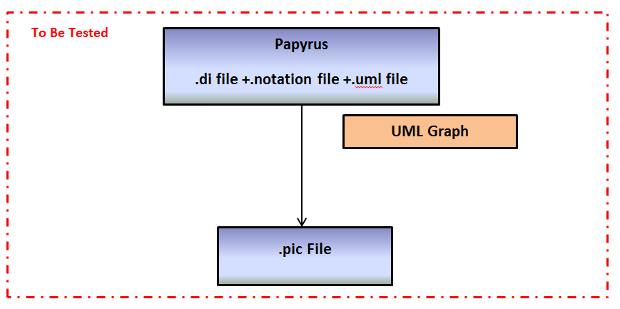

1. Structure Created and Specific Code Implementation Required

